DWIT COLLEGE
DEERWALK INSTITUTE OF TECHNOLOGY



FitNutriX – A fitness web app

A PROJECT - I REPORT

Submitted to
Department of Computer Science
DWIT College

Submitted by
Tejesh Shrestha
17th September, 2023
DWIT College
DEERWALK INSTITUTE OF TECHNOLOGY

Supervisor’s Recommendation

I hereby recommend that this project prepared under my supervision by TEJESH SHRESTHA entitled FITNUTRIX in partial fulfillment of the requirements for the degree of B.Sc. in Computer Science and Information Technology be processed for the evaluation.

…………………………………………
Shristi Awale
Program Head of Senior Year
Deerwalk Institute of Technology
DWIT College

DWIT College
DEERWALK INSTITUTE OF TECHNOLOGY

Student’s Declaration

I hereby declare that I am the only author of this work and that no sources other than that listed here have been used in this work.

…………………………………………
Tejesh Shrestha
17th September, 2023

DWIT College
DEERWALK INSTITUTE OF TECHNOLOGY

LETTER OF APPROVAL

This is to certify that this project prepared by TEJESH SHRESTHA entitled FITNUTRIX in partial fulfillment of the requirements for the degree of B.Sc. in Computer Science and Information Technology has been well studied. In our opinion it is satisfactory in the scope and quality as a project for the required degree.

……………………………………  Shristi Awale  Supervisor  Program Head of Senior Head | …………………………………………..  Shyam Sundar Khatiwada  Project Coordinator  Program Head | Project Advisory
……………………………………  Niresh Dhakal  Evaluator  Associate Director of Undergraduate Program | ……………………………………  Saurav Gautam  Evaluator  Program Head, Freshman Year

ACKNOWLEDGEMENT

Firstly, I would like to extend my heartfelt gratitude to my supervisor, Ms. Shristi Awale for her guidance and expertise. Her suggestions, support and insightful feedbacks have played a great role for the success of this project.

I would also like to thank my project coordinator Mr. Shyam Sundar Khatiwada for this gentle reminders and do’s and don’ts regarding the project. Furthermore, my friends have also played a significant role in inspiring me to come up with my project idea. I would like to take this opportunity to thank them as well.

Tejesh Shrestha
1146
17th September, 2023

ABSTRACT

The proposed project is a fitness web application that helps the users with their fitness goals and aspirations. Nowadays staying fit is not easy in this fast paced world of technology. Keeping track of all the different workouts done is a tedious task. The FitNutriX web app presents its users the opportunity to use all these features with the use of technology.

This web application brings a centralized platform for its users to calculate their BMI, log and track their workouts and view their calorie intake through the reliable Nutrition Table made available from the app.

Keywords: Body Mass Index; Food Nutrition Table; Workout Logging; Workout Info View

TABLE OF CONTENTS

CHAPTER 1: INTRODUCTION 1
1.1. OVERVIEW 1
1.2. BACKGROUND AND MOTIVATION 1
1.3. PROBLEM STATEMENT 1
1.4. OBJECTIVE 2
1.5. SCOPE 3
1.6. OUTLINE 3
CHAPTER 2: BACKGROUND RESEARCH 5
2.1. LITERATURE REVIEW 5
2.2. CURRENT SYSTEM 5
2.3. THE PROBLEM WITH CURRENT SYSTEM 6
CHAPTER 3: SPECIFICATION AND DESIGN 7
3.1. REQUIREMENT ELICITATION AND ANALYSIS 7
3.1.1. Functional Requirement 7
3.2.2. Non-Functional Requirement 7
3.3. SYSTEM DESIGN 8
3.3.1. Use Case Diagram 8
3.3.2. Flow-Chart Diagram 9
CHAPTER 4: IMPLEMENTATION AND EVALUATION 10
4.1. TOOL AND TECHNOLOGY 10
4.2. IMPLEMENTATION 11
4.3. EVALUATION AND RESULT 12
CHAPTER 5: CONCLUSION 13
CHAPTER 6 : LIMITATIONS 14
REFERENCES 15

LIST OF FIGURES

Figure 1: Use-Case Diagram 8
Figure 2: Flowchart 9
Figure 3: Waterfall Development Model 11

LIST OF ABBREVATIONS

BMI Body Mass Index
HTML Hypertext Markup Language
CSS Cascading Style Sheet

CHAPTER 1: INTRODUCTION

OVERVIEW

A web-application developed to assist users with their health and fitness goals. With three main features BMI calculation, Nutrition Value Table and Workout Logging, this application aims to empower users to make informed decisions about their fitness journey and maintain a healthy lifestyle.

BACKGROUND AND MOTIVATION

Fitness is an integral part of human life. A person who is fit physically and mentally doesn’t only look good but also possesses an ability to work more efficiently and effectively.

Physical fitness involves maintaining a healthy body through exercise, nutrition, and rest, offering benefits like improved health, increased energy, enhanced strength, and better sleep. Similarly, mental fitness is crucial, promoting stress reduction, improved mood, cognitive function, emotional resilience, and positive self-esteem.

PROBLEM STATEMENT

In today's fast-paced world, maintaining an active and healthy lifestyle can be challenging. Many individuals struggle to track their fitness activities, monitor their progress, and maintain consistency in their workout routines. Additionally, understanding proper nutrition and setting achievable goals often require specialized knowledge and guidance. The lack of an efficient and user-friendly tool often magnifies these difficulties and hinders individuals from achieving their fitness aspirations.
The FitNutriX web-based application addresses these challenges by providing a centralized platform where users can conveniently track their fitness activities, calculate their Body Mass Index (BMI), receive recommended weight ranges, plan their nutrition goals, and log their workouts. By integrating these features into a single application, FitNutriX aims to simplify the process of managing one's fitness journey and provide users with valuable insights and support along the way. The application aims to enhance user motivation, promote consistency, and ultimately help individuals achieve their health and fitness goals effectively and efficiently.

- Lack of active lifestyle
- Obesity and diseases caused due to it
- Improper form during workouts
- Lack of intake of a balanced diet

1.4. OBJECTIVE

Some of the major objectives of my project are:

- To develop a web application for users to effectively manage and monitor their fitness goals.
- To provide users with an accurate tool for calculating their Body Mass Index (BMI) based on height and weight measurements, enabling them to assess their overall health status
- To assist users in planning and tracking their nutrition goals by offering a comprehensive nutrition planner, allowing them to monitor calorie intake, and maintain a balanced and healthy diet.
- To enable users to log and track their workouts effectively, including workouts and duration providing them with a centralized platform to monitor their fitness activities and progress over time.
- To prioritize user privacy and data security by implementing robust authentication mechanisms and ensuring that users' personal information and fitness data are handled securely.
- To enable users to access correct nutritional values of several food items.
- To provide users with an easy to use UI for workout logging and viewing.

SCOPE

- User Registration
- Body Mass Index Monitoring
- Integration of a Balanced Diet
- Regular Workout Logging

1.6. OUTLINE

Preliminary Section: This section contains the title page, abstract, table of contents and list of figures.

Introduction Section: In this section, the overview of the project, the background and motivation of the project, problem statement, its objectives and scope are discussed.

Background Research Section: This section includes description, summary and critical evaluation of all the research papers studied to build a foundation of knowledge required for this project. It also includes the study of the currently available system and problems in it.
Specification and Design Section: The section consists of description of algorithms implemented and the system design as well.

Implementation and Evaluation Section: The section comprises of the tools and technologies used to build the system, description of implementation, and results obtained from testing the system.

Conclusion and Remaining work Section: The section is composed of the final findings and the remaining work of the project.

CHAPTER 2: BACKGROUND RESEARCH

2.1. LITERATURE REVIEW

The literature was categorized into three main themes: Health and Fitness Tracking, Nutritional Information, and Workout Logging. These themes were chosen to highlight the different aspects of this app and understand their interconnection.
These studies reveal the importance of user-centric app design, seamless integration of features, and the potential for video-based guidance in health and fitness apps. The findings align with the multifunctional approach of the FitNutriX app.
Collectively, the literature underscores the demand for comprehensive health and fitness apps that merge BMI calculation, Nutrition tables, and Workout logs with Tutorial videos. User-friendly interfaces with accurate data emerged as key factors in app effectiveness and user satisfaction.
This synthesis emphasizes the potential of the proposed app to meet the user demand for a centralized and feature-rich health and fitness solution. By addressing usability concerns and leveraging insights from existing research, the app can serve as a valuable tool for individuals seeking a holistic approach to well-being.

2.2. CURRENT SYSTEM

There are many websites on the internet that provide the features of BMI calculation (‘calculator.net’), displaying food nutrition value (‘nutritiontable.com’) and even logging of workouts. FitNutriX has created a platform that has centralized all these features into a single application.

2.3. THE PROBLEM WITH CURRENT SYSTEM

I believe that the primary issue with the current system is its fragmentation. Users are often required to scout through numerous websites to gather a single piece of information.
The second concern revolves around data authenticity. Many available websites are not reliable and can display false information.
The FitNutriX app has a centralized system in which BMI calculation, Nutritional Table and Workout logs and tutorials can be accessed in a single app. This solves the major feature fragmentation issue.

CHAPTER 3: SPECIFICATION AND DESIGN

3.1. REQUIREMENT ELICITATION AND ANALYSIS

The requirements for the system were analyzed with careful research and consideration.
The app must have a clear user interface which must be easy to use. It must have proper security for all registered users and keep their personal information private.

3.1.1. Functional Requirement

- User shall be able to log into their account.
- User shall be able to enter his height and weight and calculate BMI.
- Nutritional values of food items shall be shown accurately.
- Users shall be able to log their daily workouts effectively.
- The user shall log their workout activities, including exercises, duration, and additional notes.
- The app shall display user's progress over time, including changes in weight, BMI, and other relevant metrics.
- The app shall store user data securely, including personal information, BMI calculations, nutrition goals, and workout logs.

3.2.2. Non-Functional Requirement

- The app must implement appropriate user authentication.
- The application must be able to prevent unauthorized access to sensitive information.
- The application interface must be user friendly.

3.3. SYSTEM DESIGN

3.3.1. Use Case Diagram

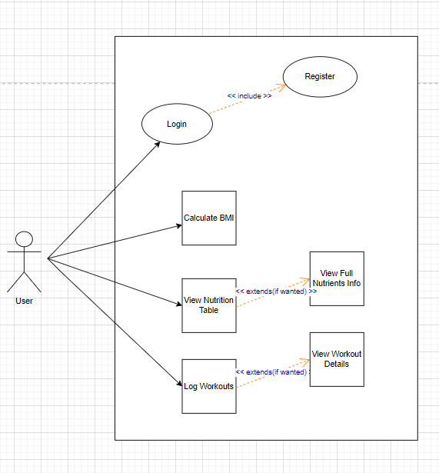

Figure 1: Use-Case Diagram

3.3.2. Flow-Chart Diagram

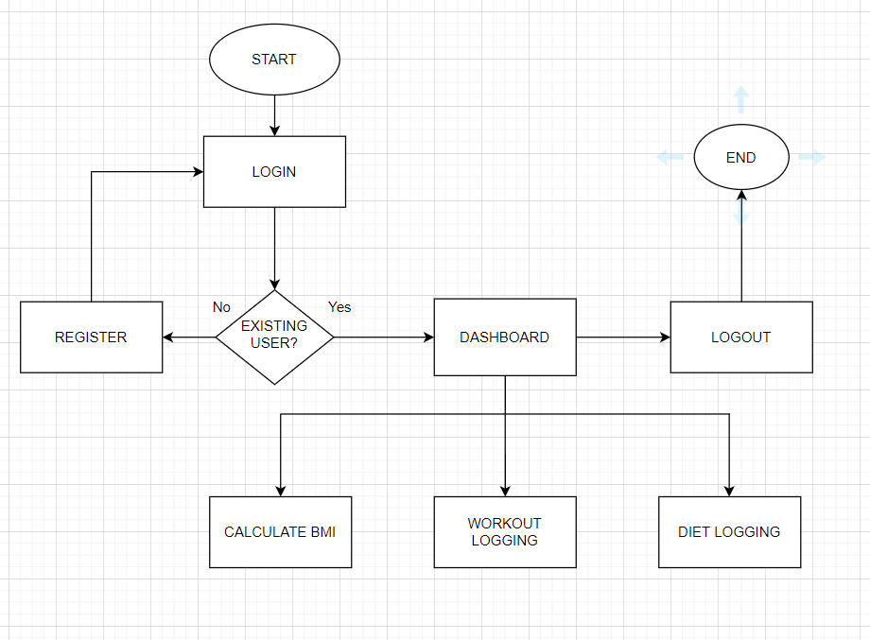

Figure 2: Flowchart

CHAPTER 4: IMPLEMENTATION AND EVALUATION

4.1. TOOL AND TECHNOLOGY
The tools and technologies I used are:

- System Specification
Microsoft Word: used for documentation
- System Design
draw.io: used for flowcharts and figures
- System Development
MERN stack:-
Mongodb: used as a database for storing workout information and logs
Express package: a package in nodejs used for generating server side APIs
Reactjs: used for all frontend designs
Nodejs: Js framework used for backend architecture
- System Testing
Postman: used for testing APIs

4.2. IMPLEMENTATION

The proposed project focuses on the development of a web based fitness app that provides accurate BMI values and easy UI for workout logging. The waterfall development model has been used to develop this project.

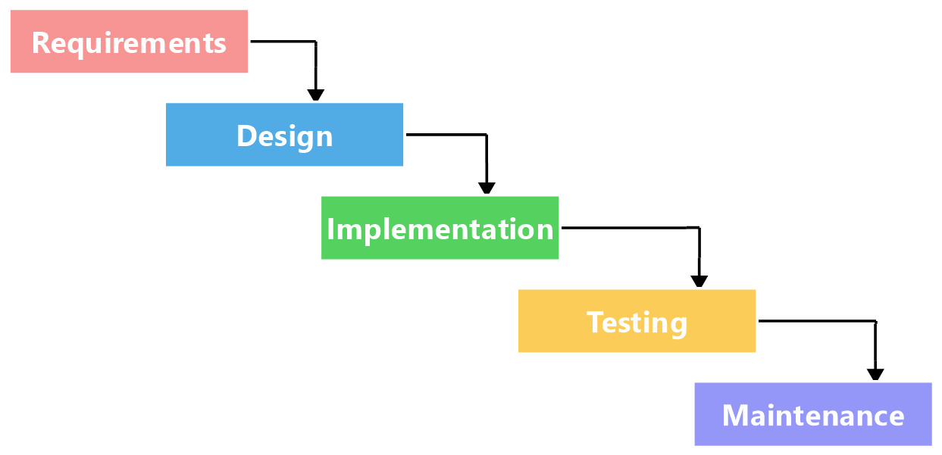

Figure 3: Waterfall Development Model

4.3. EVALUATION AND RESULT

The evaluation process primarily consisted of making the app user-friendly and intuitive. The frontend for the user interface was developed using simple HTML, CSS and ReactJs. In addition to this, user registration and login were tested using Postman. The three main features BMI calculation, Workout Logging and Food Nutritional Table are showcased in an easily accessible manner for the user enhancing the overall user experience and helping them in their fitness journey.
However, the evaluation also unveiled areas for improvement. While the system’s performance was generally satisfactory, the UI needs a lot of improvement. Furthermore, optimizing the integration of the frontend with the backend is crucial to ensure that data flows seamlessly between these components, enhancing the overall efficiency of the application. The system remains committed to providing consistent results and accurate outputs, aligning perfectly with the needs and expectations of users. These findings from the evaluation process will serve as a valuable roadmap for further refinements, with a strong emphasis on enhancing usability, data integrity, and the overall user experience.

CHAPTER 5: CONCLUSION

The proposed app is a comprehensive health and fitness companion designed to facilitate a healthy lifestyle.
It encompasses three main features:
- BMI Calculator: The app includes a Body Mass Index (BMI) calculator, allowing users to quickly assess their body's health by inputting their height and weight. The users may input their height in feet and weight in kg as those are the most commonly used metrics here in Nepal. The BMI calculation provides users with valuable insights into their overall fitness level.
- Nutrition Table: The app offers an extensive food nutrition table that provides detailed information about the nutritional content of various foods. Users can easily access data on calories, macronutrients, vitamins, and minerals, aiding in informed dietary choices.
- Workout Logs and Videos: For fitness enthusiasts, the app enables users to log their workout sessions, track progress, and set goals. It also provides access to a library of workout videos, offering guided exercise routines and expert tips.

CHAPTER 6 : LIMITATIONS

Every system in the real world has its limitations. For FitNutriX, the accuracy of nutritional information and workout data relies on the quality of the underlying data sources. If the data sources have inaccuracies or are not regularly updated, it can lead to incorrect recommendations. The system's Food Nutritional Table relies on a database of foods and their nutritional information. If this database is not comprehensive or lacks certain regional or specialty foods, users may not find their desired items. Also, since it is a web-application, it requires a strong and reliable internet connection for proper functionality and results. Addressing these limitations and actively seeking user feedback can help improve the FitNutriX system over time and make it more reliable as well as user-friendly.

REFERENCES

[1] (n.d.). Retrieved August 1, 2023, from fullstackopen: www.fullstackopen.com

[2] Altexsoft. (2022,07,26). Retrieved 06 08, 2023, from https://www.altexsoft.com/blog/non-functional-requirements/

[3] Nutritionix API Documentation. (2022). Retrieved June 2023, from Nutritionix: https://docs.google.com/document/d/1_qkObMTZvO0qUEAxROrN3bwMujwAN25sLHwJzliK0/edit#heading=h.lfnb9dtubrav

[4] BMI. (n.d.). Retrieved July 2023, from RegisteredNurseRN.com: www.registerednursern.com

[5] draw.io. (n.d.). Retrieved 06 12, 2023, from https://app.diagrams.net/#G1YmzVMS0CB-kKwpCYmtfPENaRNP6M84-1

[6] Exercises. (n.d.). Retrieved August 2023, from Youtube.com: www.youtube.com

